and Primitive

* Evaluates if both conditions are true
* Short circuit operation if encountered a false statement
* First falsy

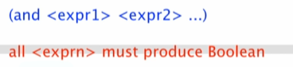

Example:



or Primitive

* Evaluates if either condition is true
* Short circuit operation if encountered a true statement
* First truthy

not Primitive

* Reverse the Boolean return